**Capstone Project**

**The Battle of Neighborhoods (Part 1)**

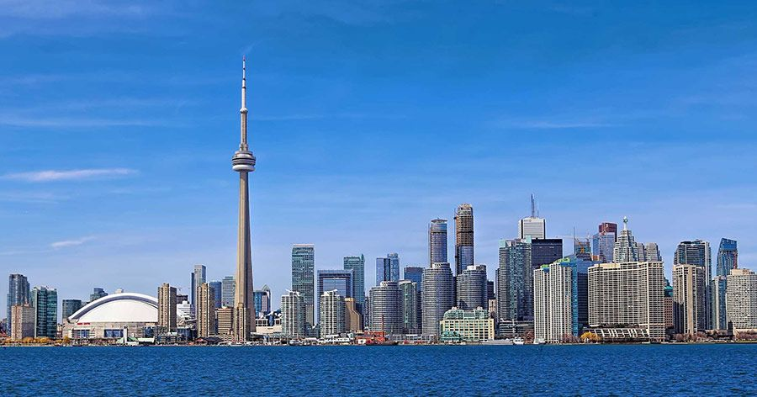

Canada is a country in the northern part of [North America](https://en.wikipedia.org/wiki/North_America). Its [ten provinces and three territories](https://en.wikipedia.org/wiki/Provinces_and_territories_of_Canada) extend from the [Atlantic](https://en.wikipedia.org/wiki/Atlantic_Ocean) to the [Pacific](https://en.wikipedia.org/wiki/Pacific_Ocean) and northward into the [Arctic Ocean](https://en.wikipedia.org/wiki/Arctic_Ocean), covering 9.98 million square kilometers (3.85 million square miles), making it the world's [second-largest country by total area](https://en.wikipedia.org/wiki/List_of_countries_and_dependencies_by_area). Its southern and western [border with the United States](https://en.wikipedia.org/wiki/Canada%E2%80%93United_States_border), stretching 8,891 kilometers (5,525 mi), is the world's longest bi-national land border. Canada's capital is [Ottawa](https://en.wikipedia.org/wiki/Ottawa), and its three [largest metropolitan areas](https://en.wikipedia.org/wiki/List_of_census_metropolitan_areas_and_agglomerations_in_Canada) are [Toronto](https://en.wikipedia.org/wiki/Toronto), [Montreal](https://en.wikipedia.org/wiki/Montreal), and [Vancouver](https://en.wikipedia.org/wiki/Vancouver).

Canadians of South Asian descent are one of the largest non-European ethnic groups in Canada (second only to Chinese-Canadians), making up the tenth largest ethnic group in the country. In the 2016 census, 1,963,330 people of South Asian origin were recorded as calling Canada ‘home’.

Canada contains the world's [eighth largest Indian diaspora](https://en.wikipedia.org/wiki/Indian_people). The largest group of Indian Canadians are of [Punjabi](https://en.wikipedia.org/wiki/Punjabis) origin, accounting for around 50 percent of the Indo-Canadian population.[[3]](https://en.wikipedia.org/wiki/Indo-Canadians#cite_note-3) The highest concentrations of Indian Canadians are found in the provinces of [Ontario](https://en.wikipedia.org/wiki/Ontario) and [British Columbia](https://en.wikipedia.org/wiki/British_Columbia), followed by growing communities in [Alberta](https://en.wikipedia.org/wiki/Alberta) and [Quebec](https://en.wikipedia.org/wiki/Quebec) as well, with the majority of them being foreign-born.

**Business Problem**:

So looking at the diverse Indian population in Canada, it’s a good Idea to start an authentical Indian restaurant to fulfill the taste demand of the Indian in Canada and extend the business of the restaurant chain across the boundaries.

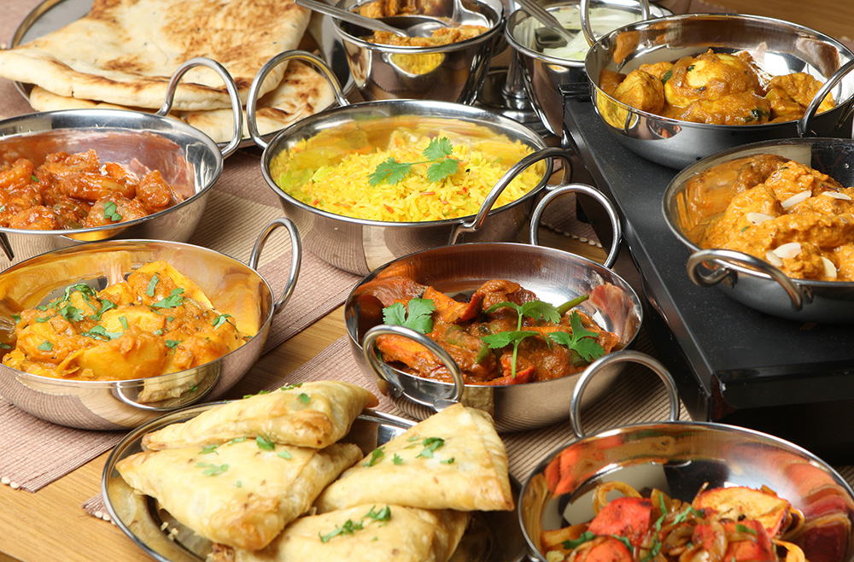

Let the restaurant chain decides to start their journey from Toronto.

To find a the answers to following:

* List all major parts of Toronto that already has Indian restaurant.
* Find the best location in Toronto for Indian Cuisine.
* Find areas in Toronto have Potential Indian restaurant Market.
* Find areas in Toronto lack Indian restaurant.
* Which is the best place in Toronto to stay if you prefer Indian Cuisine.